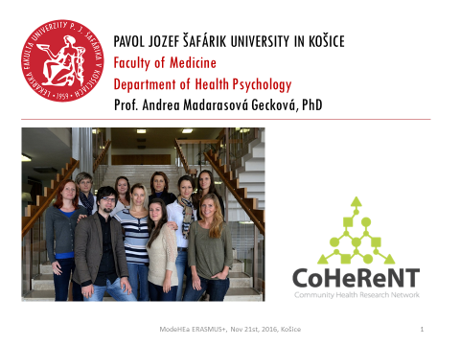 | 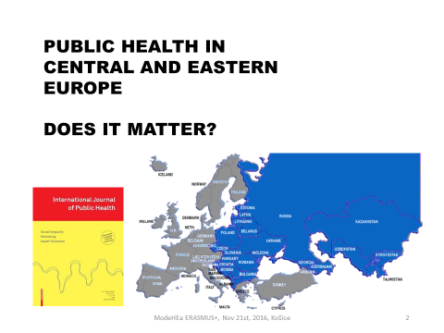
I will start from a wider perspective asking if public health in CEE really matter.
Is there anything in public health practice and research in CEE what we should know, we should share and do we share it?
http://www.springer.com/public+health/journal/38

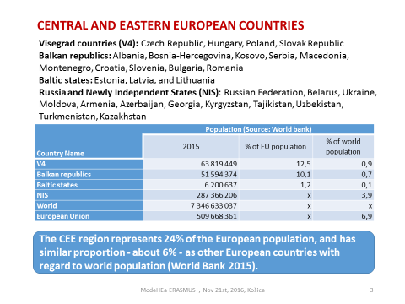 | CEE could be divided on Visegrad countries, Balkan republics, Baltic states, and Russia. Newly Independend States might be included as well despite it belongs to Central Asia.  Table describes population in 2015 based on World bank data.  The CEE region represents 24% of the European population,  and has similar proportion - about 6% - as other European countries with regard to world population.  So IT IS a considerable proportion of population and I believe it is also interesting part of world with regard to public health issues taking into account transforming health care systems, variety of population, minorities, cultural differences any many other topics
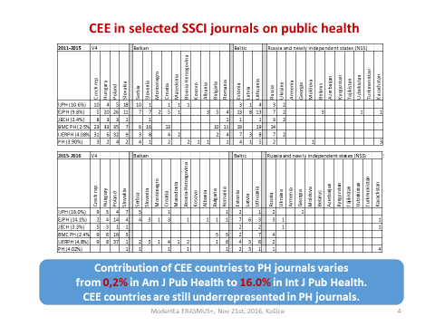 | These tables describes contribution of CEE countries in selected Public Health journals in period 2011-2015 and in last two years.  I selected Int J Pub H, Eur J Pub H, J Epid Com H, BMC PH, Int J Env Res Pub H, Pub H and Am J Pub H which published only 5 from more than 2000 papers in period 2011-2015 and none in 2016 therefore I did not include it into the table.  As you might see, contribution of CEE countries varies from 0.2% in Am J Pub Health to 16% in Int J Pub Health.  While some countries are quite well presented, others are absent in PH journals.  Generally we might say that CEE countries are underrepresented in PH journals.
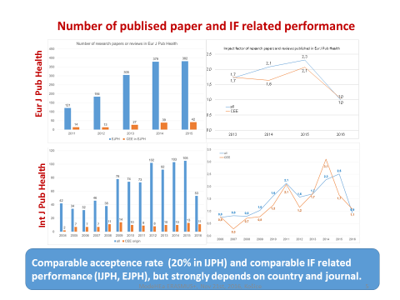 | Number of published papers as well as IF related performance could be another indicator.  Blue bars represent number of papers published by a journal at all and yellow one those originated in CEE.  Graphs on right side represent IF performance of all papers and those originated in CEE.  As you might see these papers has comparable IF related performance in both journals.  The true is that it strongly depends on a country and journal.
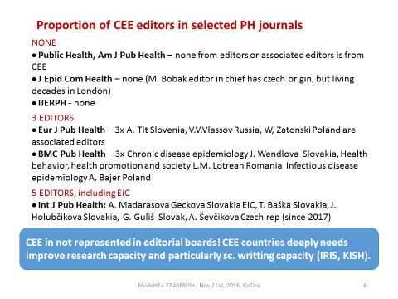 | One of the reasons why CEE are unrepresented in journals might be its absence in editorial boards.  4 from selected journals did not have any editor from CEE.  2 journals have 3 editors from CEE  Int J Pub Health has 5 editors from CEE
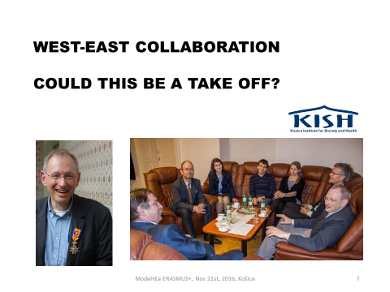 | But representation in editorial boards is not enough and authors from CEE needs to improve their research capacity and particularly capacities for scientific communication.  The solutions might be collaboration with excellent universities elsewhere on trainings programs, summer schools or graduate schools.  So, let’s think about a west-east collaboration as a possible take off for CEE.
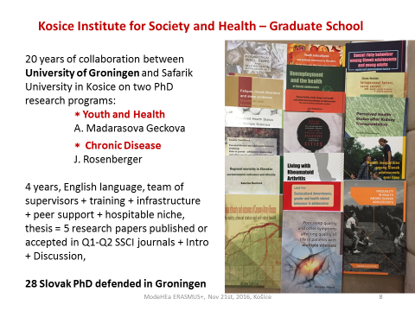 | 20 years ago this university starts to collaborate with University of Groningen in Netherlands in research on social determinants of health in vulnerable groups of population  and the result of this collaboration was a Graduate school Kosice Institute for Society and Health which offers two research programmes for PhD students, one targeting children and adolescents and second one patients with chronic disease and their quality of life.  PhD. programme lasted 4 years, English is used as a working language and students are supervised by international team of supervisors.  For successful running of this graduate school we developed necessary infrastructure, peer support and it could not exist without hospitable niche offered by host faculty.  Thesis consist of 5 research papers published or accepted in SSCI journals in Q1 or Q2, accompanied with introduction and discussion and published as a book.  First PhD thesis was defended in 2001 and since then 28 Slovak PhD students defended their thesis in Groningen within this programme. Several others are ongoing.
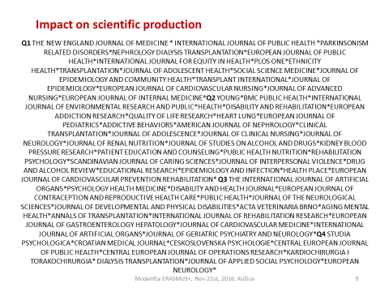 | Such collaboration has a huge impact on scientific production and this slide just describes a variety of journals we already published in across variety of quartiles and variety of fields AND variety of departments within our faculty and university which are collaborating with us.
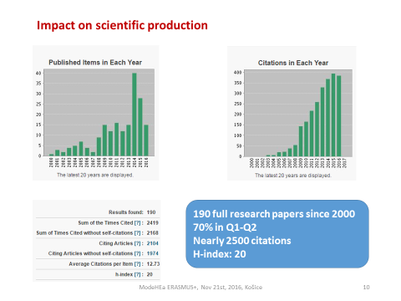 | Graphs describes how scientific production and citations grow up year by year resulting in nearly 200 research papers, 70% of them in upper two quartiles, nearly 2500 citations and h-index equal 20. This year 20 research papers are already accepted or published in SSCI journals.
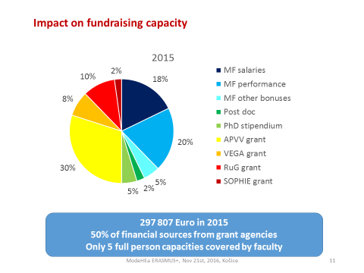 | Such collaboration increase not only scientific production, but also fundraising capacity of the team.  The blue parts are money invested by our faculty on salaries and bonuses.  Our faculty cover salaries for 5 full person capacities. All other salaries has to be covered from other sources.  Green parts are stipendiums for PhD students or postdocs. The yellow one are money from national grant agencies and the red one are money from abroad.  Last year we were able to attract nearly 300 000 Euro and half of this amount came from national or international grant agencies.
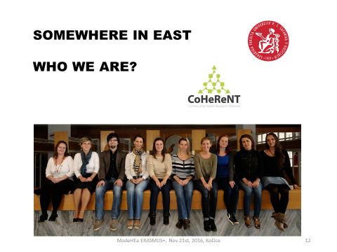 | It takes two decades and it would not be possible without support or our university and faculty and it would not be possible without a team of unbelievable gifted, motivated, and deeply engaged young people who were attracted by this work and work very hard and with full heart. I am very proud on them so let me introduce this team.
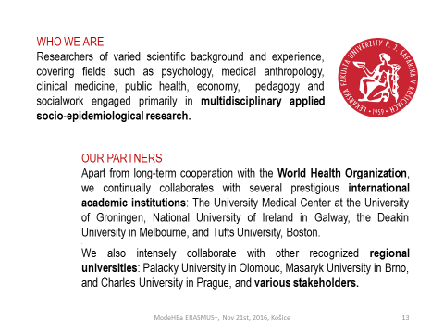 | We are researchers of varied scientific background and experience covering fields like psychology, public health, clinical medicine, medical anthropology, social work, and economy, engaged primarily in multidisciplinary applied socio-epidemiological research.  Apart from long-term co-operation with World Health Organization we continually collaborate with several prestigious international academic institutions, regional universities and various stakeholders.
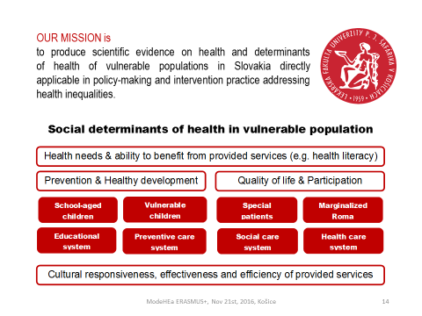 | Our mission is to produce scientific evidence on health and determinants of health in vulnerable populations directly applicable in policy-making and intervention practice addressing health inequalities. A „leitmotive“ are social determinants of health and vulnerable population. We focused on school-aged children including vulnerable groups of school-aged children AND on adults confronted with chronic disease or marginalization. So we try to explore healthy development of school-aged children on one side and quality of life and participation on the other side aiming to understand better health needs and ability to benefit from services provided by educational system, preventive, social and health care systems. We are particularly interested in cultural responsiveness, effectiveness and efficiency of provided services.
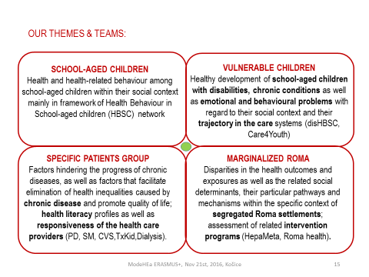 | There are following four main themes or teams:  Two focused on school-aged children and two on adult population.  First team focus on health and health related behaviour among school-aged children within their social context mainly in framework of Health Behaviour in School-aged children network.  Second team explore healthy development of school-aged children with disabilities, chronic conditions including emotional and behavioural problems paying particular attention to their trajectory in the care systems.  How to eliminate health inequalities caused by chronic disease and promote quality of life in patients with chronic disease is explored by third research group. A lot of work was done in patients with PD, SM, patients passing cardio surgery or kidney transplantation and in dialysed patients.  In present time they work intensively exploring health literacy profiles and responsiveness of health care providers.  The topic of fourth group are disparities in the health outcomes and exposures as well as the related social determinants, their particular pathways and mechanisms within the specific context of segregated Roma settlements. This team focus also on assessment of related intervention programs.
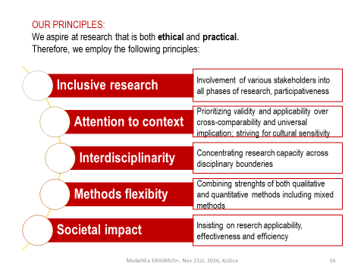 | We aspire at research that is both - ethical and practical.  Therefore, we employ the following principles:  Inclusive research - we are trying to involve various stakeholders into all phases of research, we go for participatiness as much as possible  Attention to context - we are trying to prioritize validity and applicability over cross-comparability and universal implication, we consider cultural sensitivity as very important  Interdisciplinarity - we are trying to concentrate scattered research potential/ capacity across disciplinary boundaries  Methods flexibility - we are trying to combine strengths of both qualitative and quantitative methods including mixed methods  Societal impact - we insist on research applicability, its effectiveness and efficiency  What we really want is research based on stakeholders’ demand which lead to evidence based actions.  We are trying to involve various stakeholders and to produce evidences for various stakeholders including policy makers, frontlines, target population, public, and media. Therefore we are trying to build our dissemination capacity as well.
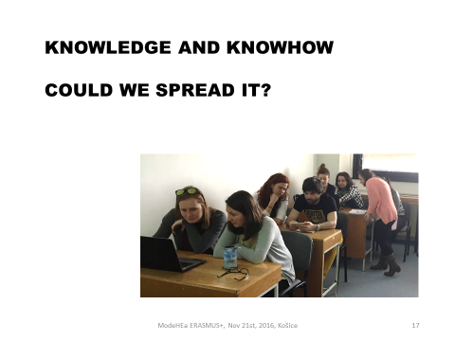 | Definitely we have valuable knowledge and knowhow, but how could we spread it?  We have and expertise in two main fields: in building research capacity and in psychological, social and cultural aspect of health.
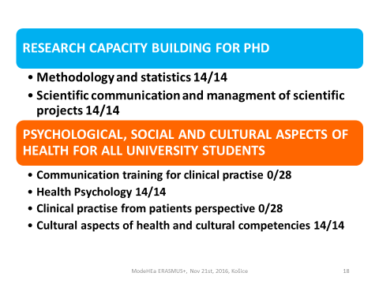 | The first one is dedicated to medical PhD students, the second one is open to all university students via interdisciplinary certificated block. In both cases we talk mostly about elective subjects. Only methodology and statistics is compulsory but only for PhD students in internal medicine, public health and epidemiology.
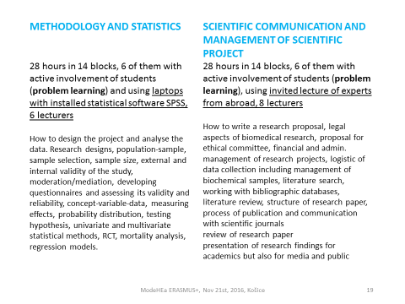 | I will start with subjects aiming to build research capacity of PhD students.  In all our educational activities we are trying to use full variety of team expertise and therefore we combine more lecturers specialised on specific topics and in some cases we enriched it by invited lectures of experts from other universities or institutions.  Methodology and statistics consist of 14 blocks, while 6 of them with active involvement of students via problem learning. We are using mobile computer lecture room with installed statistical software.  Our aim is to teach students how to design the project and analyse the data going across various topics described on a slide.  Scientific communication and management of scientific project is similar. 6 from 14 blocks are with active involvement of students via problem learning, 8 lecturers used to be combined including one our colleague from Groningen delivering lecture on legal aspects of biomedical research and ethical committee procedures and second one from Denmark delivering block on writing research proposal for international grant agencies.  Our aim is to learn students how to write a research proposal, handle financial and administrative management of research project, logistic of data collection in field including management of biochemical samples and then issues related to scientific communication from working with bibliographic database, elaborating literature review, via writing research paper, communication with journal up to presentation of research findings for academics, media and public.
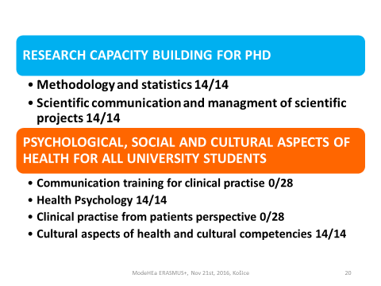 | 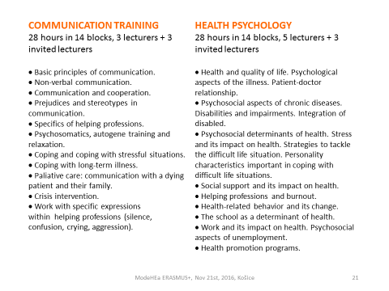
I guess, this two subjects do not need a special introduction as it use to belong to natural core knowledge provided to medical students.
Again, we used specialisation of lecturers for specific topics to stimulate transfer of best possible expertise in particular topic. For the same reason we include also invited lectures from experts out of the faculty.

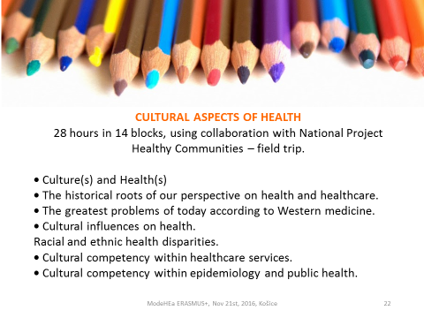 | Cultural aspects of health and cultural competence of health care services has increasing importance not just because of recent migration crisis in Europe, but mainly because cultural variability always was a core aspects of effectiveness and efficiency in any services or interventions.Our aim is to increase understanding as well as sensitiveness of students, future service providers or developers to it via lectures provided by cultural anthropologist. Using collaboration with National project Healthy Communities a field trip is organized as well.
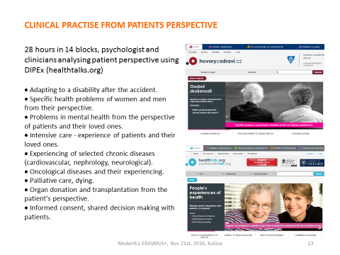 | Clinical practice from patients perspective consist of 28 hours in 14 blocks of education delivered by team of psychologist and clinicians analysing patient perspective using selected authentic videos from DIPEX project. We harvest from our collaboration with University in Olomouc involved in DIPEx network aiming to improve personal experiences of health and illness via qualitative analyses of their perspectives and archiving it on web portal in a systematic way which allows patients, their families, health care providers, as well as students and teachers to use it. As you might see we selected some topics and our aim is to guide discussion with students using authentic experiences of patients combined with experts’ opinion.
