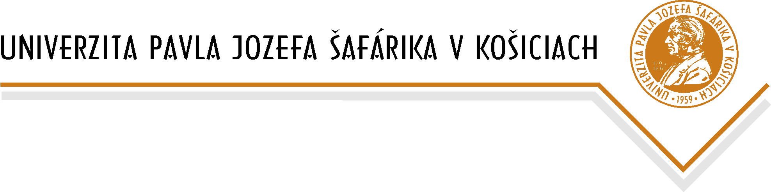
Information liability pursuant to Article 13 Regulation of the European Parliament and of the Council No. 2016/679 of 27 April 2016 on the Protection of Individuals with Regard to the Processing of Personal Data and on the Free Movement of Such Data, repealing Directive No. 95/46/EC (General Data Protection Regulation) (GDPR)

Pavol Jozef Šafárik University in Košice, Šrobárova 2, 041 80 Košice, CRN: 00397768, is the Information System Operator, which concerns the persons concerned - the UPJŠ in Košice University Library users (hereinafter the "UPJŠ UL"), and includes their personal data, e-mail: rektor@upjs.sk

Data Protection Officer:
Mgr. Gabriela Ciberejová, e-mail: zodpovedna-osoba@upjs.sk

The purpose of processing the personal data: providing the library and information services
Legal basis for the processing of personal data: Provision of Section 18 a) of Law Act No. 126/2015 Coll. on Libraries and on Amendments to Law Act No. 206/2009 Coll. on Museums and Galleries and on the Protection of Objects of Cultural Value and on the Amendment of Law Act of the Slovak National Council No. 372/1990 Coll. on Offenses as amended by Law Act No. 38/2014.

Personal data shall only be processed by authorized persons who have been properly instructed.

Retention time: Personal data of the UPJŠ UL user shall be kept until the expiry date of 2 years from expiry of the User's Card and the user has no obligation to the UPJŠ UL.

There is no automated decision making at UPJŠ, including the profiling referred to in Articles 22 (1) to (4) GDPR.

Advice on the rights of the person concerned:
The person concerned shall be entitled to the following, upon written request from the Operator:
(a) to require access to his/her personal data;
(b) to require the correction, erasure or limitation of the processing of his/her personal data;
(c) to object to the processing of personal data,
(d) to transferability of his/her personal data;
(e) to withdraw his/her consent to the processing of personal data whenever personal data
are processed on this legal basis,
(f) the right to lodge a complaint with the supervisory authority; i.e. Office for Personal Data Protection of the Slovak Republic.

The above-mentioned rights of the UL user are specified in Articles 15 to 21 GDPR.

